# EduTech -affordable electronics solution for underprivileged students during COVID-19

**A Project Report**

***Submitted by***

## Riya Tendulkar

## Vaishnavi Rathod

***Under the Guidance of***

Prof. Vijayetha Thoday

***in partial fulfillment for the award of the degree of***

## B. Tech (Computer Engineering)

At



**MPSTME, Mumbai**

**Nov, 2020**

## DECLARATION

I, **Vaishnavi Rathod and Riya Tendulkar**, Roll No. **E016 and E047** B. Tech (Computer Engineering), V semester understand that plagiarism is defined as anyone or combination of the following:

1. Un-credited verbatim copying of individual sentences, paragraphs or illustration (such as graphs, diagrams, etc.) from any source, published or unpublished, including the internet.
2. Un-credited improper paraphrasing of pages paragraphs (changing a few words phrases, or rearranging the original sentence order)
3. Credited verbatim copying of a major portion of a paper (or thesis chapter) without clear delineation of who did wrote what. ( Source: IEEE, The institute, Dec. 2004)
4. I have made sure that all the ideas, expressions, graphs, diagrams, etc., that are not a result of my work, are properly credited. Long phrases or sentences that had to be used verbatim from published literature have been clearly identified using quotation marks.
5. I affirm that no portion of my work can be considered as plagiarism and I take full responsibility if such a complaint occurs. I understand fully well that the guide of the seminar/ project report may not be in a position to check for the possibility of such incidences of plagiarism in this body of work.

Names: Vaishnavi Rathod, Riya Tendulkar

Roll Nos.: E016, E047

Place: Mumbai

Date: 03.11.2020

## CERTIFICATE

This is to certify that the project entitled **“ EduTech - affordable electronics solution for underprivileged students during covid-19.”** is the bonafide work carried out by **Vaishnavi Rathod and Riya Tendulkar** of BTech, MPSTME (NMIMS), Mumbai, during the V semester of the academic year **2020-2021**, in partial fulfillment of the requirements for the Course Programming Language.

___________________

Prof. Vijayetha Thoday

Internal Mentor

_______________________ ________________________

Examiner 1 Examiner 2

## Table of contents

**CHAPTER NO. TITLE PAGE NO.**

1. PROJECT INTRODUCTION 5
2. MODULES IMPLEMENTED 6
3. SCREENSHOTS 8
4. CONCLUSION & FUTURE SCOPE 30
5. SOCIETAL APPLICATION (If any) 30

**Project Introduction**

For our project, we have made a website **“EduTech”** which aims at providing under privileged people with the electronic necessities required for online education in times of Covid-19. To do this we let people sell second hand electronic devices like laptops, desktops, mobiles and tablets at cheap rates or even for free and under privileged people can buy these devices. We provide a platform for buying as well as selling and the aim of our website is to basically connect these 2 entities. Our website is completely dynamic and real-time and requires no interference from us, ie, the seller will add devices to sell which get stored in our database and the buyer can buy these devices.

**Modules Implemented**

1. **Homepage**

Home page describing our website-

1. Nav Bar with links to about us, contact us, login and register
2. Different hamburger menus for buyer and seller upon login/register with links to respective personality
3. A short description of our site
4. A description of who can buy at our site
5. Description of why you should sell
6. How to sell
7. Our impact showing the real time data from our database
8. Our mission
9. Testimonials of under privileged children
10. Footer with contact details, short para about our website and links to pages
11. **Registration**

First there is a pre-registration form which asks you if you are a buyer or seller and sets a session variable accordingly. If you are a buyer then you need to provide your annual income details and college id/proof. Then you are redirected to the registration form where basic details are asked. A person cannot have the same username and email, there is validation for that. Password validation and recheck is present as well. Validation is done with HTML, JS and PHP. Your details are fed into the tables depending on the type of user you are – Buyer or Seller.

1. **Login**

A module for the already registered users of our website. The login page prompts the user to enter their respective username and password. After submitting their entry, they are redirected to an authentication page. It displays whether the entered username and password were correct or not. If correct it lets the user continue and redirects them to the homepage (according to their being a buyer or seller). If it is incorrect, the user is redirected to the login page again where they can re-enter the correct information.

1. **Update Profile**

This lets the user view their profile. It displays the profile picture, their details like name, username, email, age, birthday and address. It also gives the user an option to change any of the profile details and when submitted, the changes are made accordingly. It also gives the user an option of updating the profile, change username or password and deleting their profile.

1. **Seller**

In seller module you can add and update your devices as well as see the status of your devices.

1. **Add Device**: Lets you add a new device- can be a laptop, mobile tablet and desktop and price validation is done according to the type of device you want to see.
2. **My Devices**: Shows the details of your current devices which are present in the database. It shows the status – sold or unsold. Upon clicking on the view-button a detailed description of the device along with the picture is displayed.

For devices that are sold, you can view the details of the buyer of the specific device.

For unsold devices you can update the device.

This page extracts data from all the tables in the database to retrieve the device details and to check if the device is sold or not, if it is sold then data from the order-items table is checked to get the buyer id and then using the buyer id the buyer details are displayed.

There are filters as well to show specific results.

1. **Update Device**: Shows a description of the current details of the device. There is a form which is prefilled with the current details of the device and you can change whichever parameter you want to. There is also an option to delete the device.
2. **Buyer**

A buyer can view the devices to buy from, access the cart and the items in it and also update the profile details.

1. **See devices**: we have a display of all the devices available for sale from the database. We display their name, type of devices, their picture, their price and a little description. There is an add to cart button on these devices from where they can add the devices to their cart.
2. **Cart**: After checking all the devices and adding them to the cart when you come to the cart the details of the devices are displayed along with the seller details. You also have an option to delete the item from the cart. An order summary with the total number of items and the total amount is also displayed. After confirming the cart items, the buyer can move forward to payment. There he will have to enter the billing details and credit/debit card details to complete the payment. Once the payment is complete, the order will be placed and the buyer will be redirected to the homepage for further exploring.
3. **Update profile**: the buyer can update any of the details mentioned in their profile. In addition to that they can also change their username or password or even delete the account.
4. **About Us**

Here we have our mission, our story of how and why we started the website. It contains a map of where delivery of our products is available. We also have some testimonials from our employees about how they feel working with us.

1. **Contact Us**

In contact us, the address, contact number and email id provided with a form to contact us.

1. **Terms and Conditions**

It contains the terms and conditions of use of the registered person on our website. It states the rules that the user must abide by and states the different responsibilities of the buyer and the seller for using the website.

**Screenshots**

Homepage

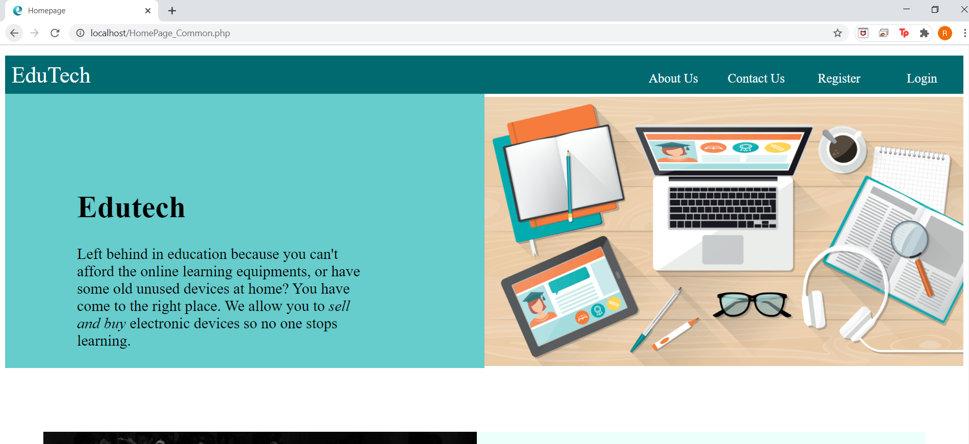

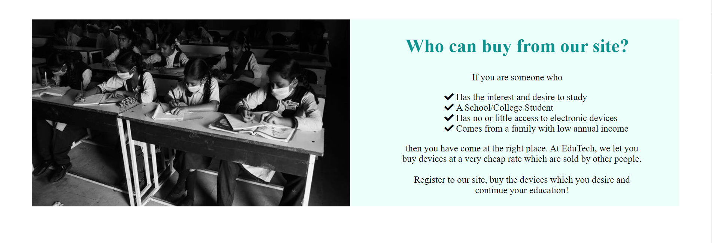

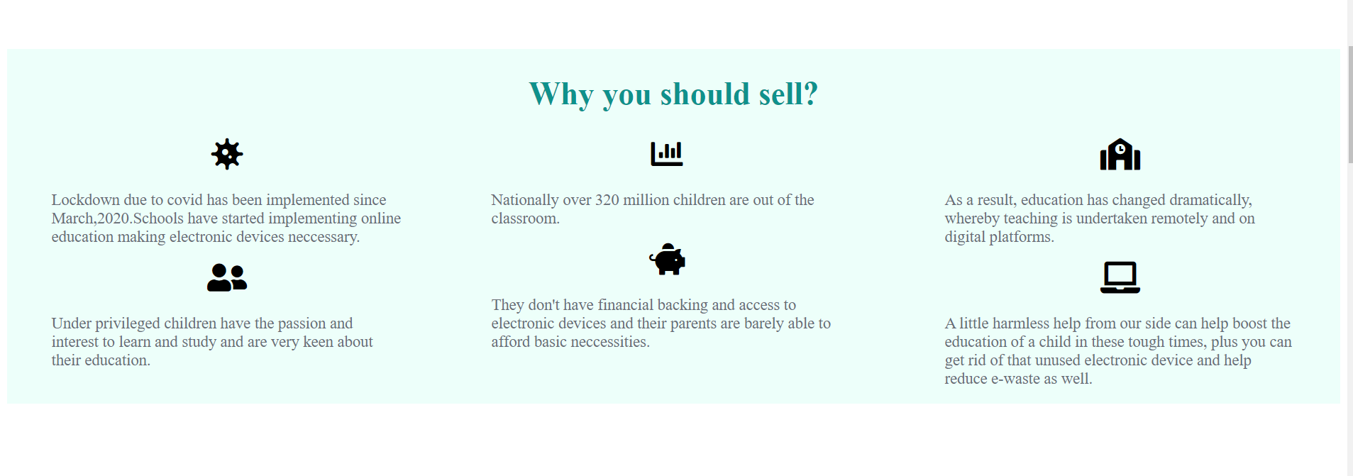

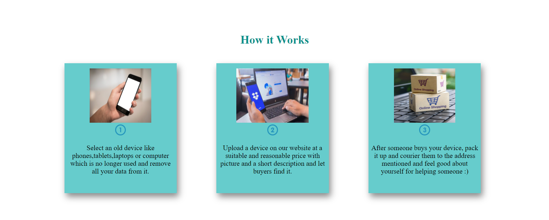

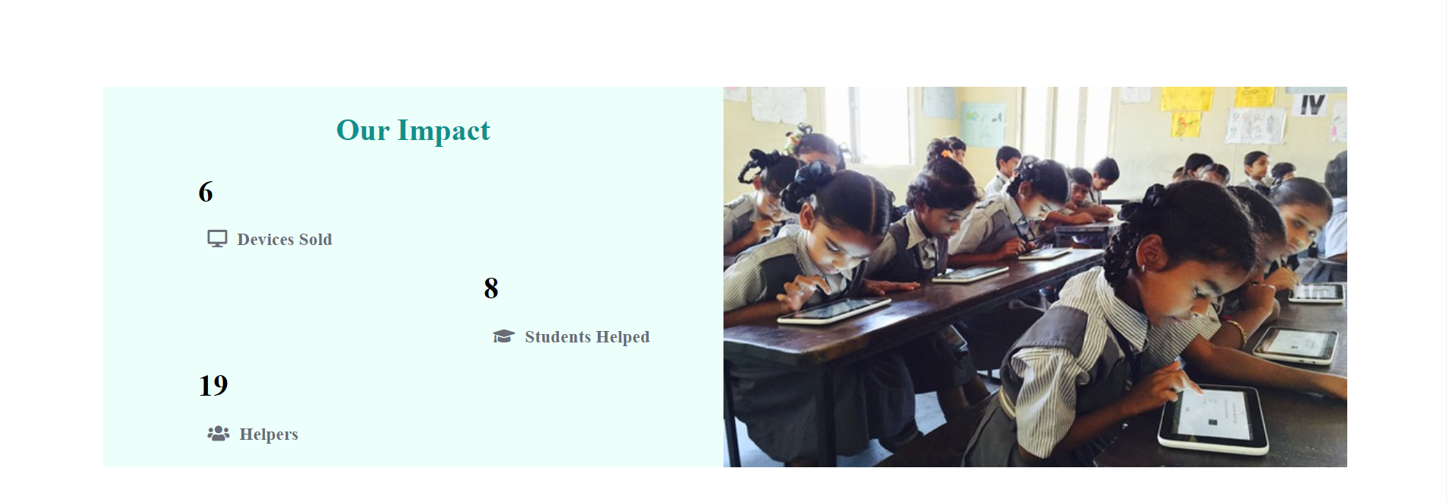

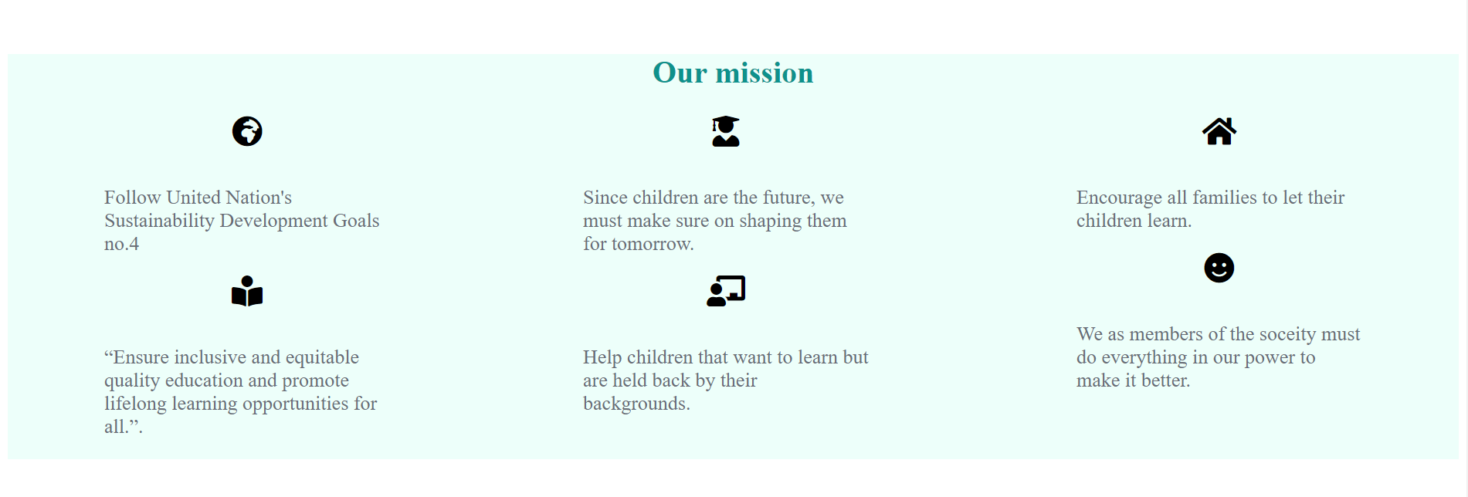

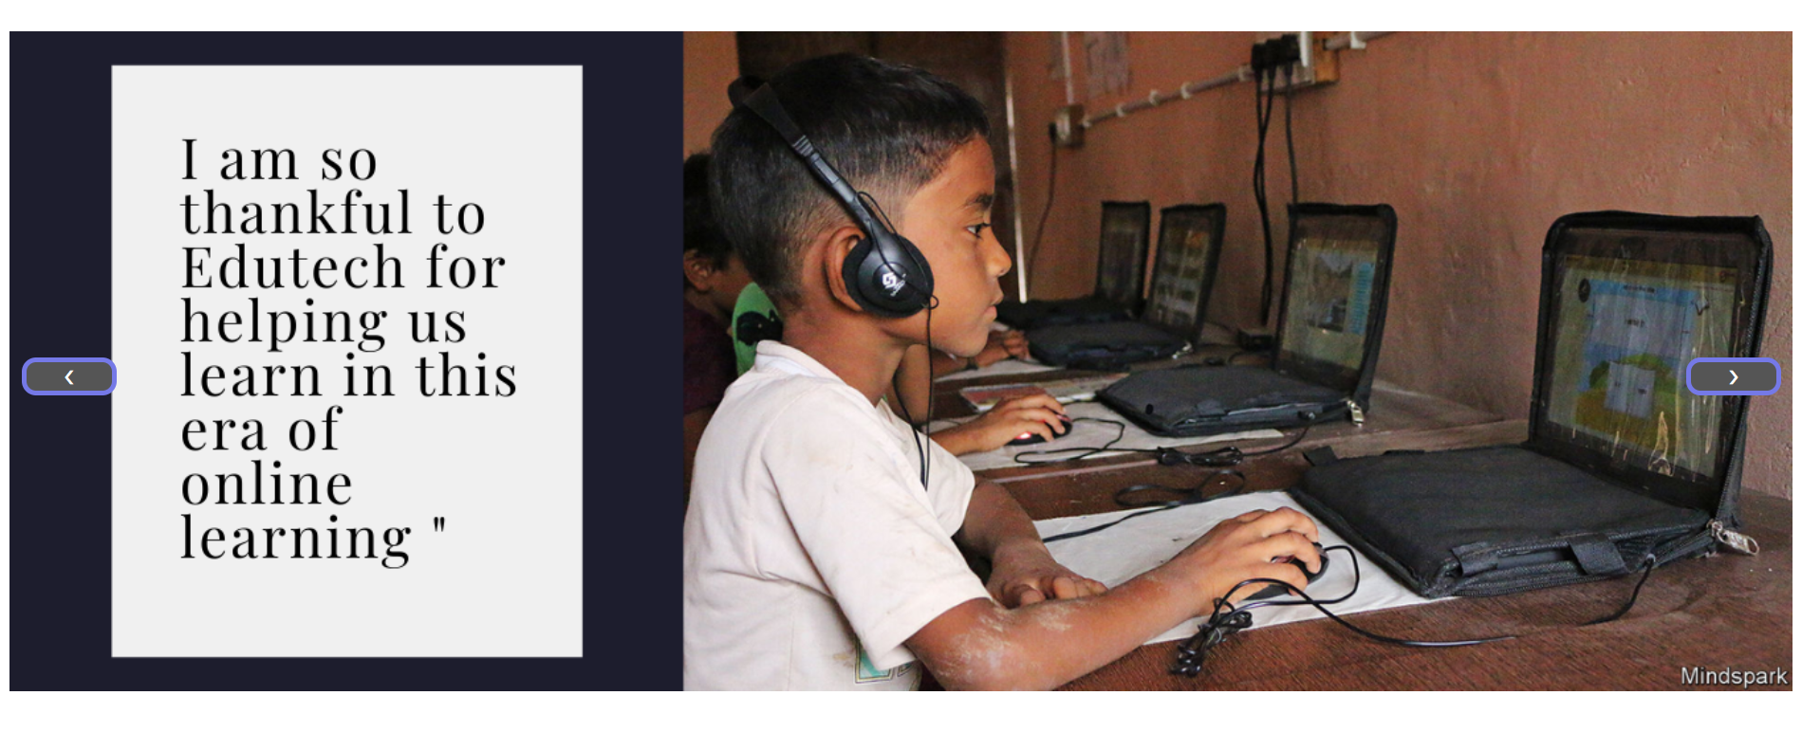

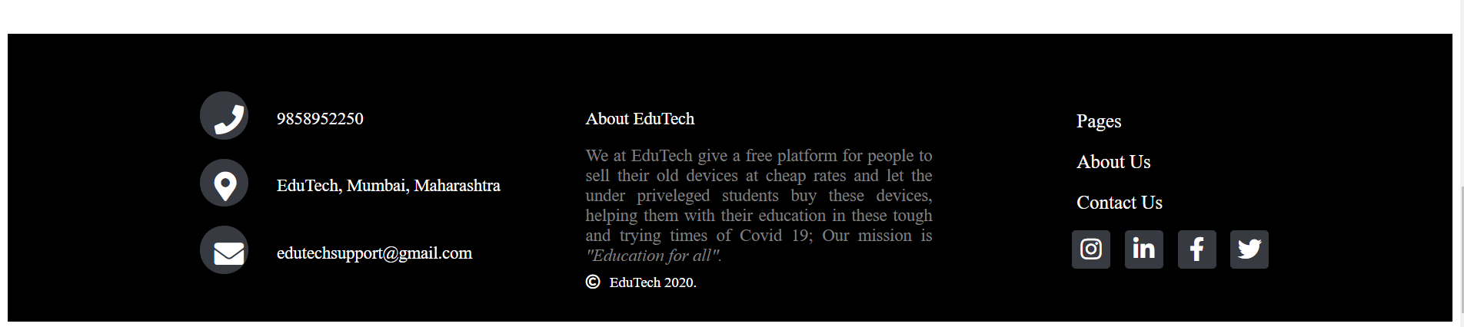

Registration

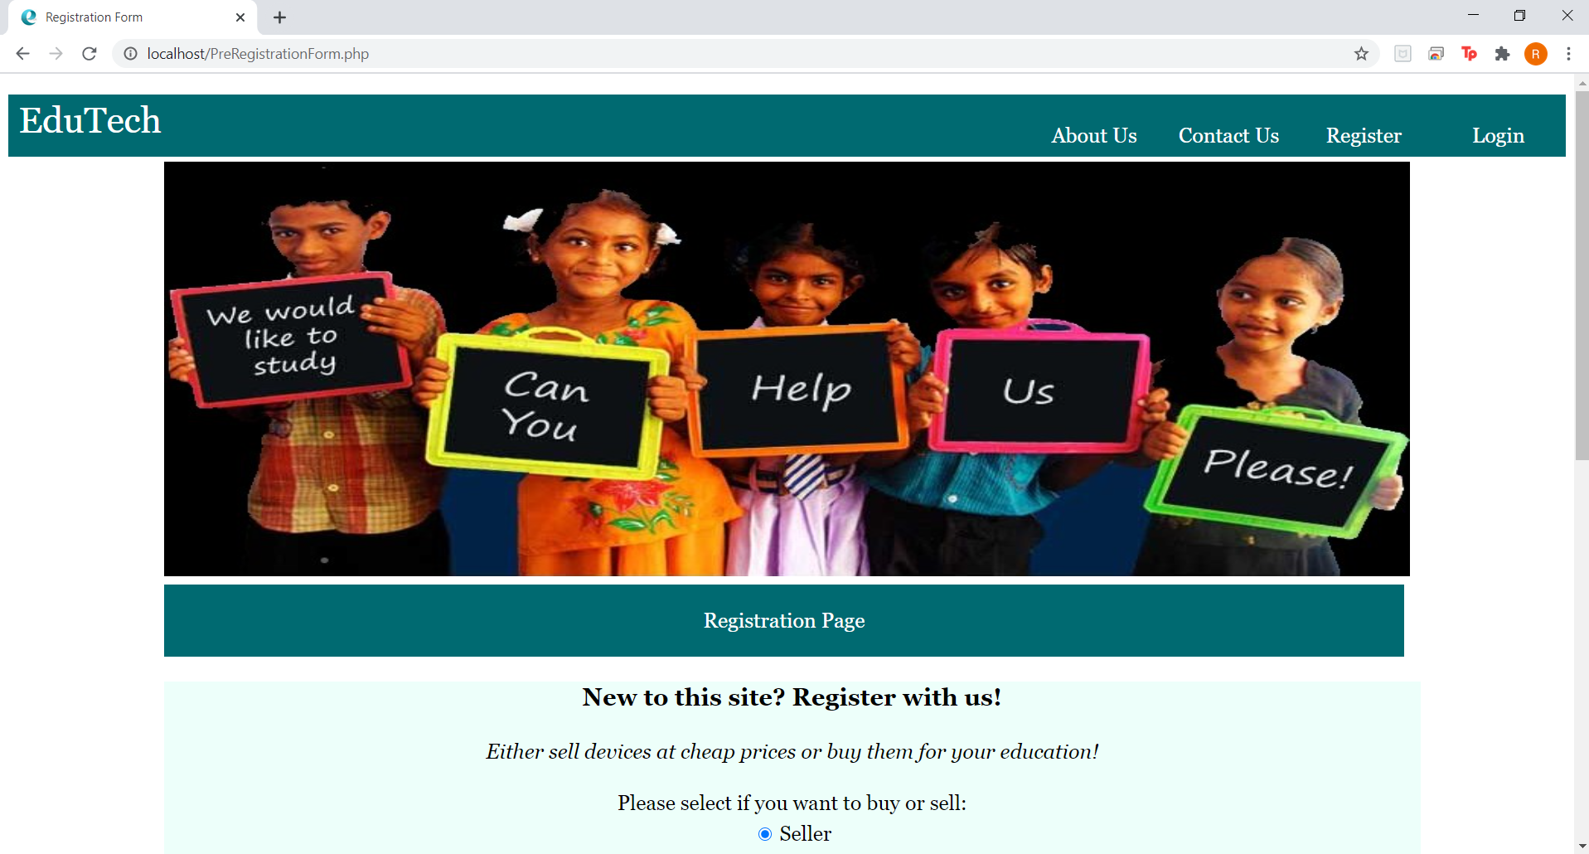

On clicking on buyer, dynamic input fields

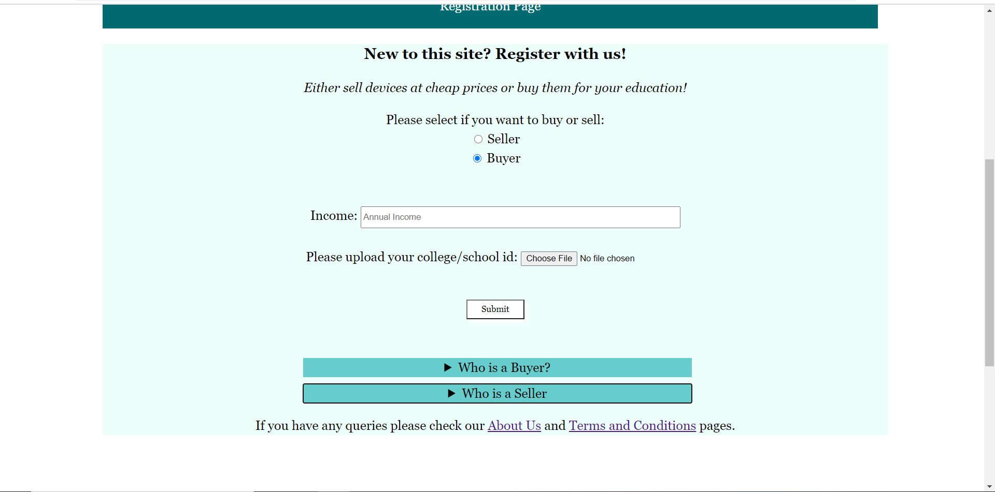

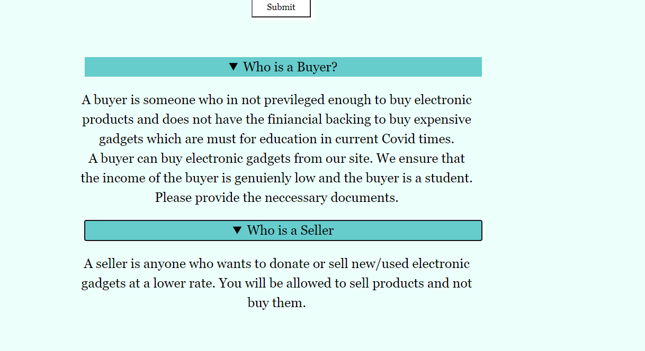

Registration Page:

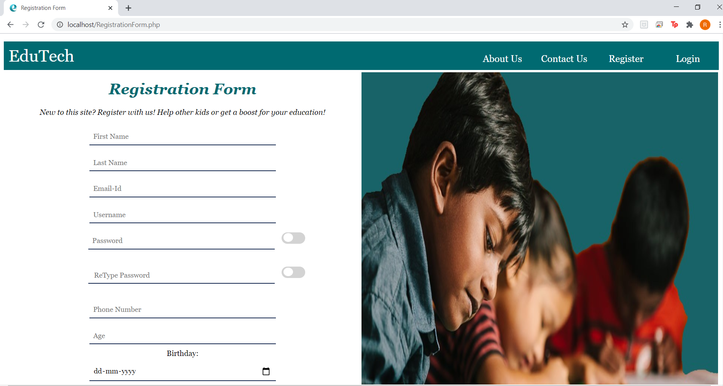

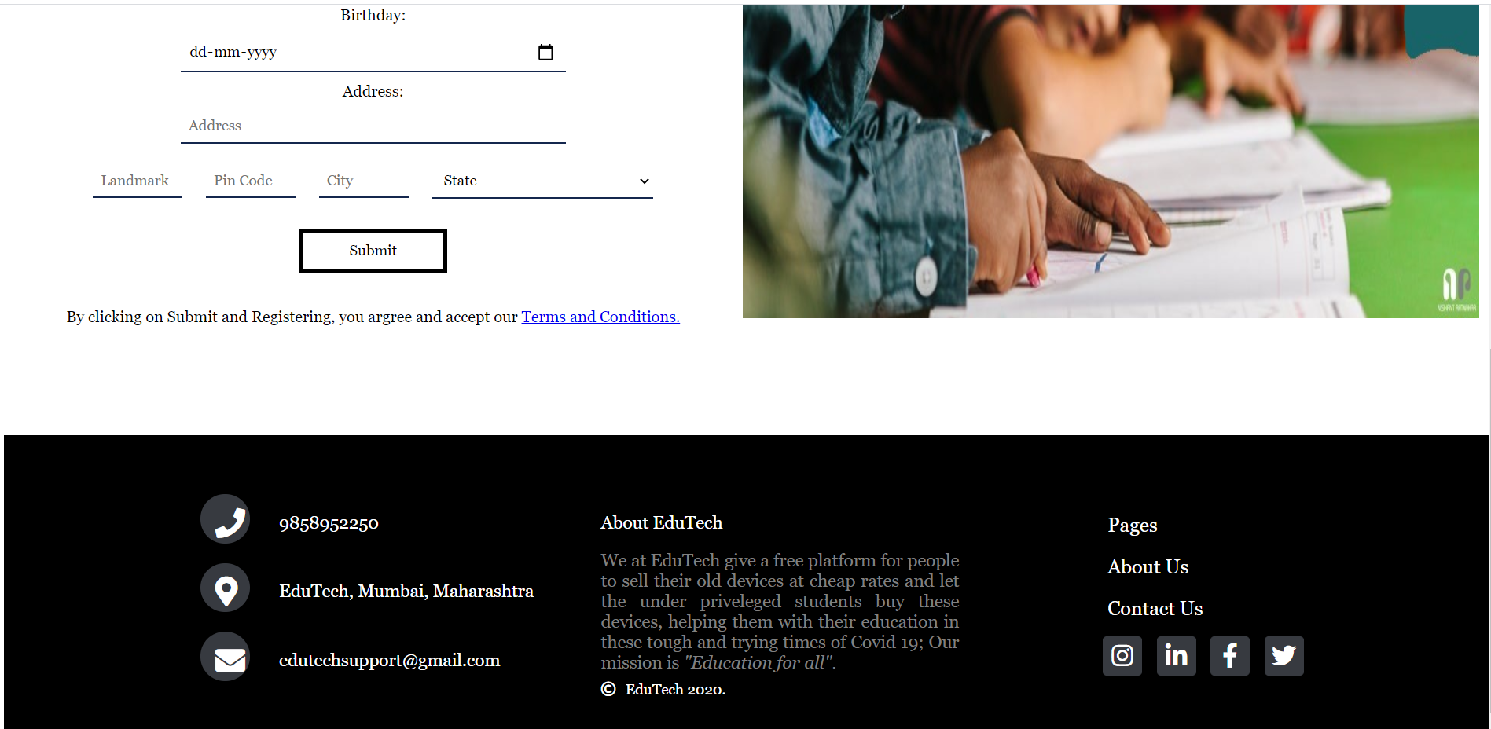

Login

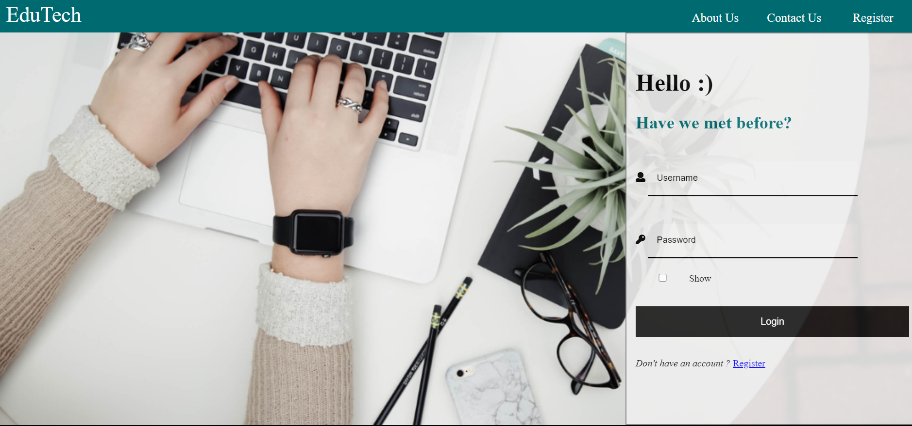

if login details are correct, user is directed to homepage. If incorrect, this is displayed.

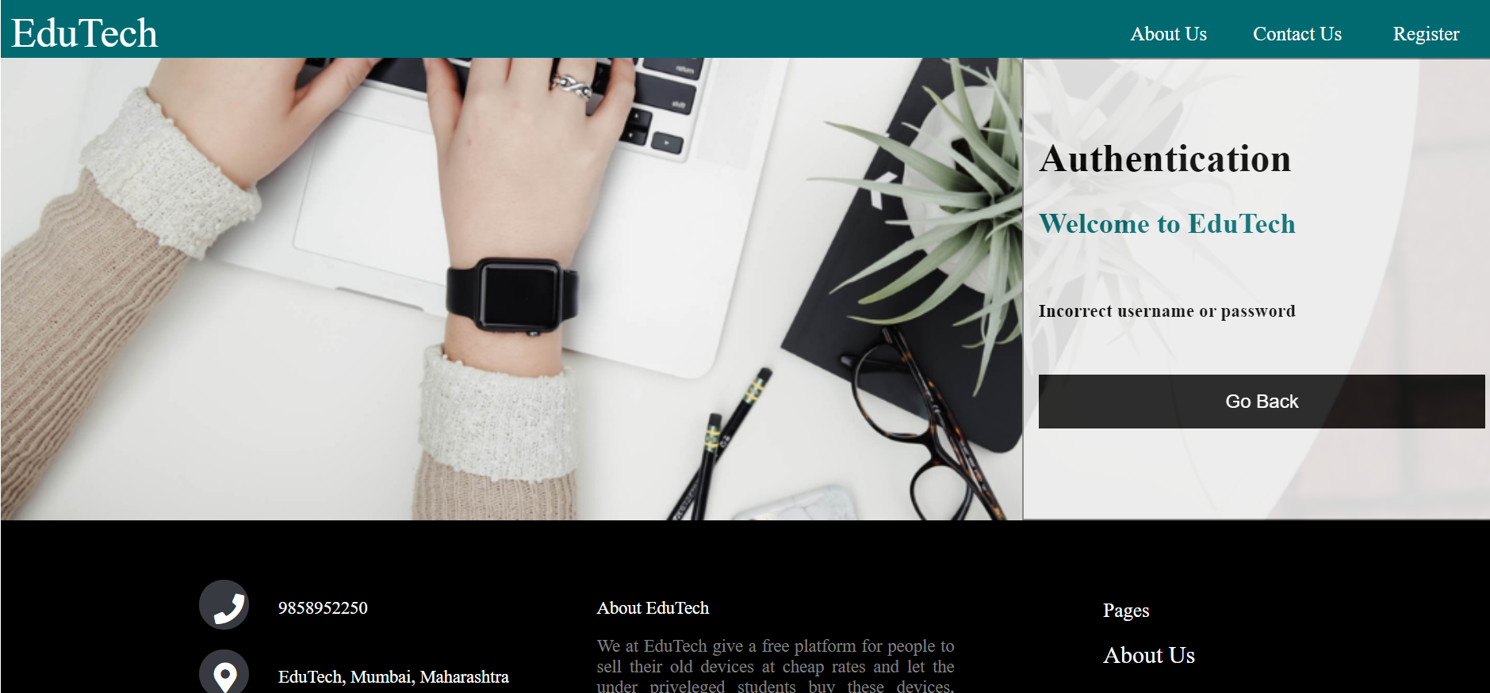

Seller

Seller Homepage with hamburger menu

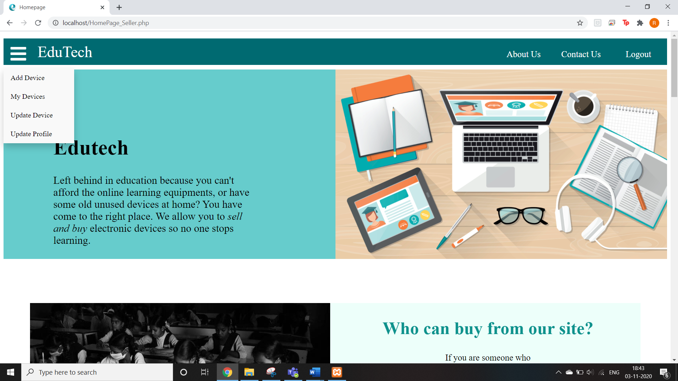

Add Device Page

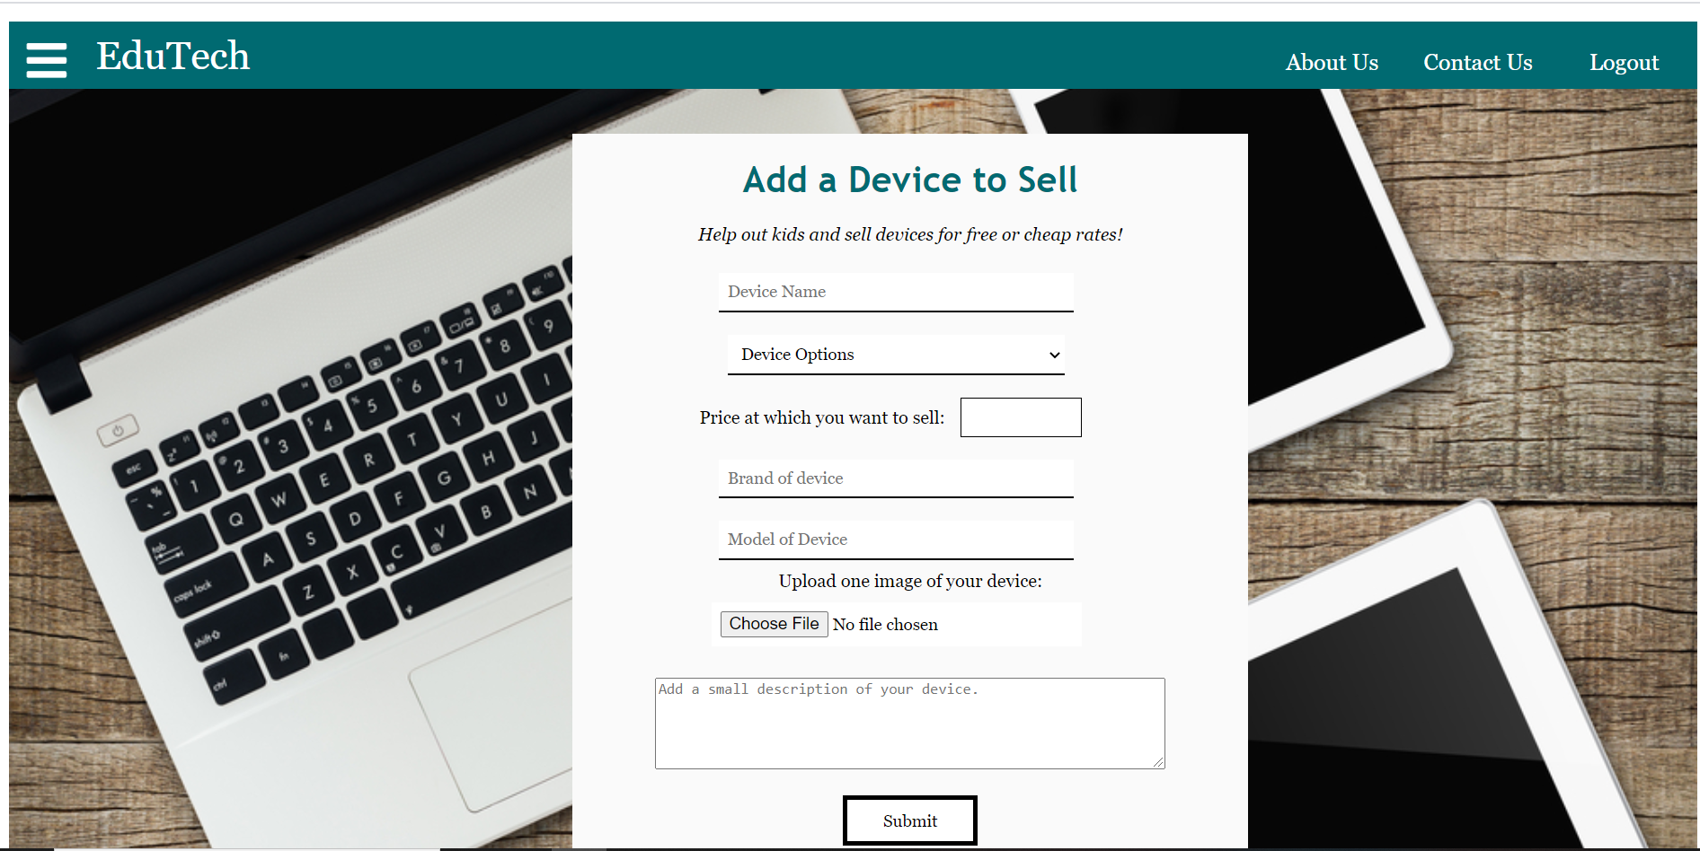

My Devices

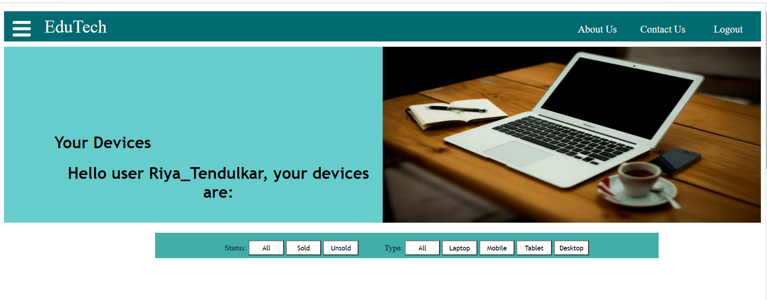

Filters in my devices:



Devices:

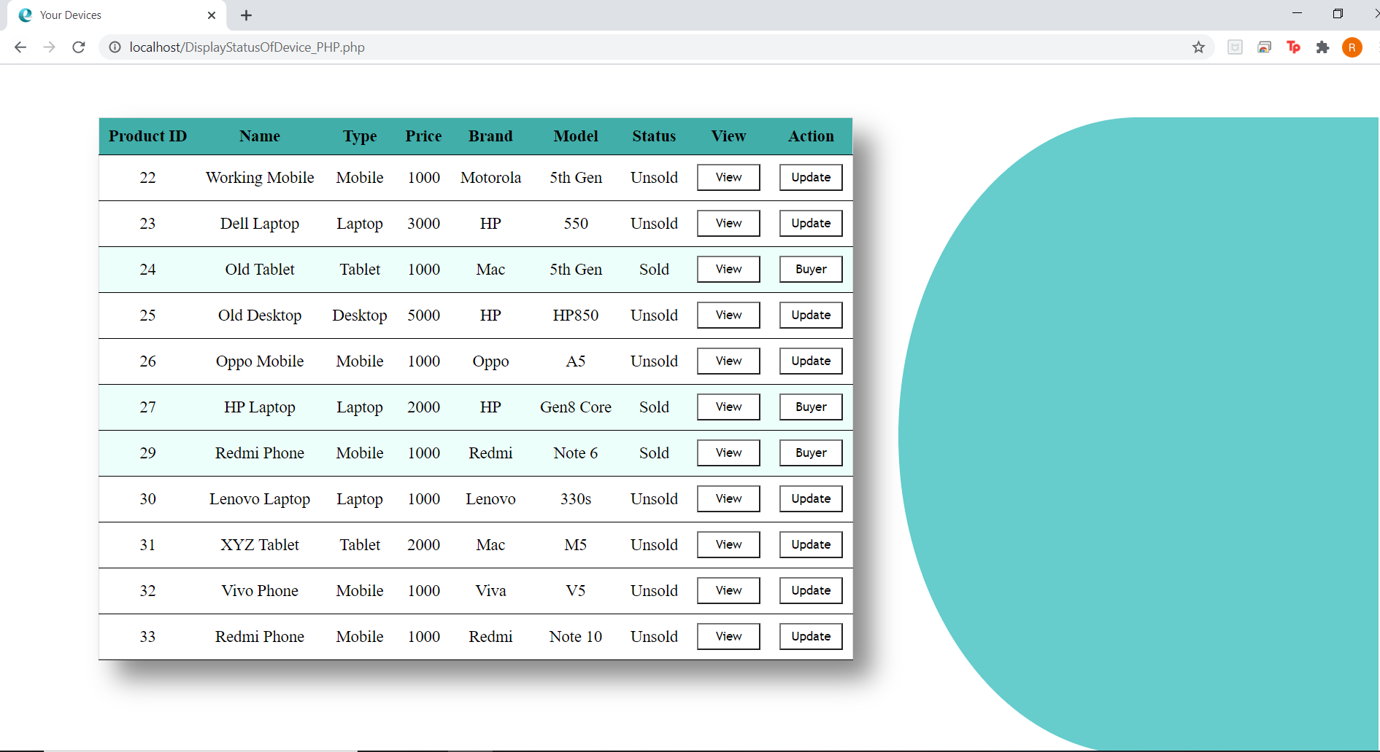

On clicking view on any device:

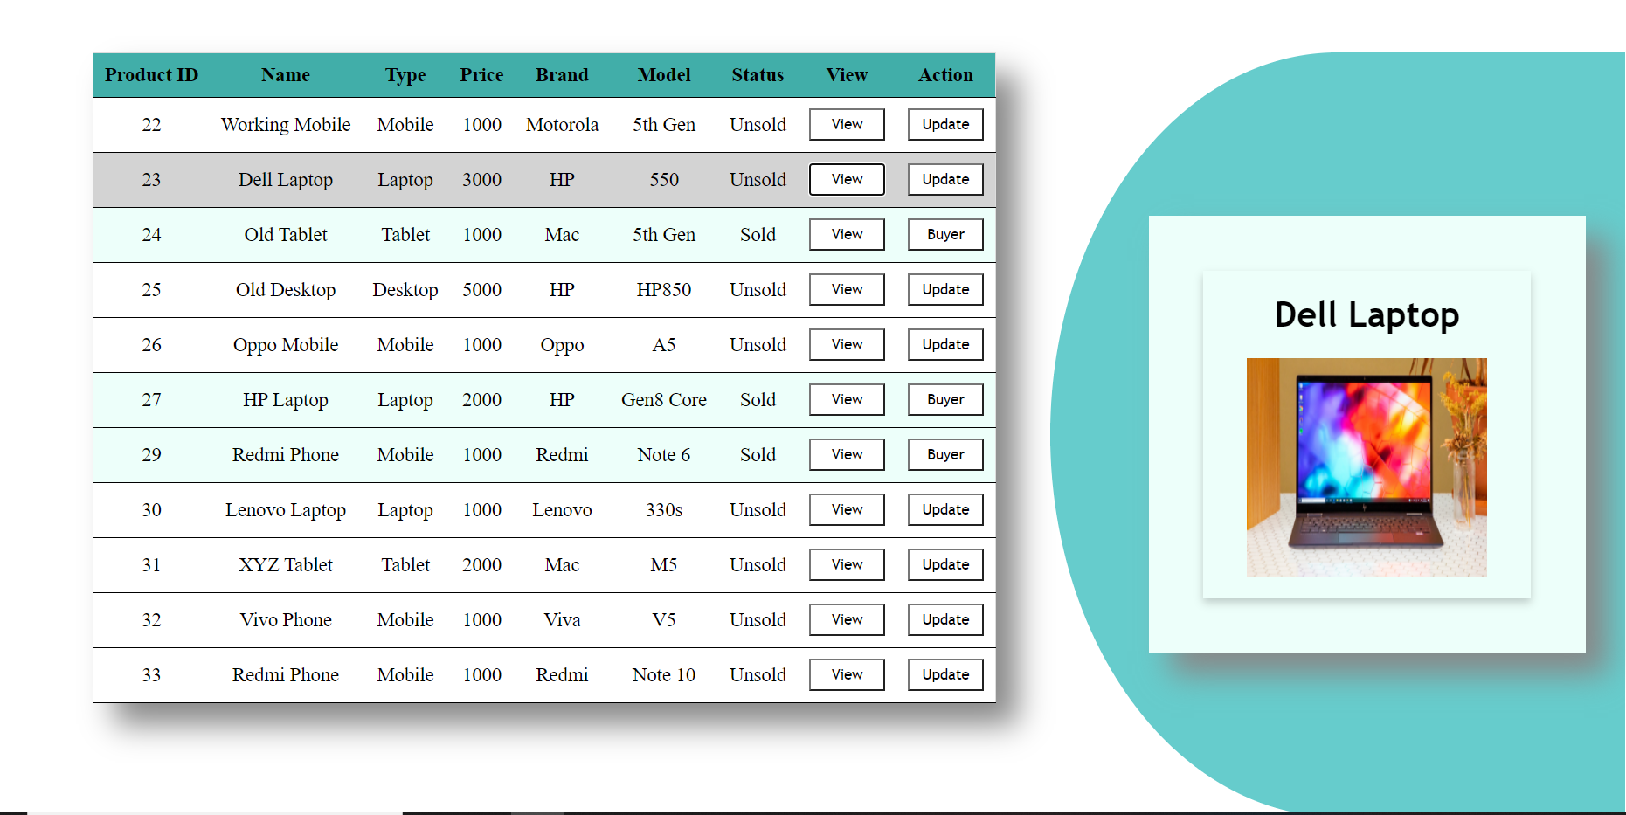

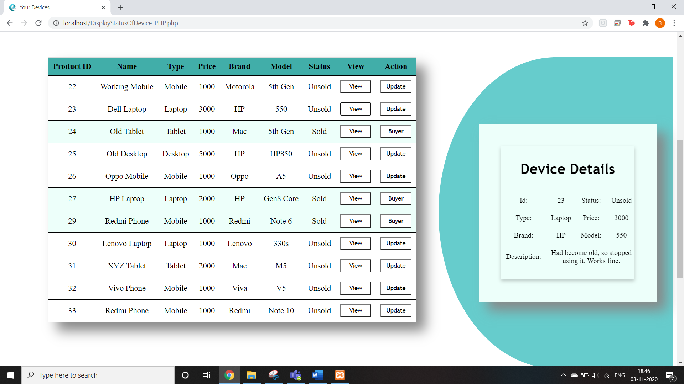

On hovering, the details of the device are displayed.

For sold devices, buyer details are displayed:

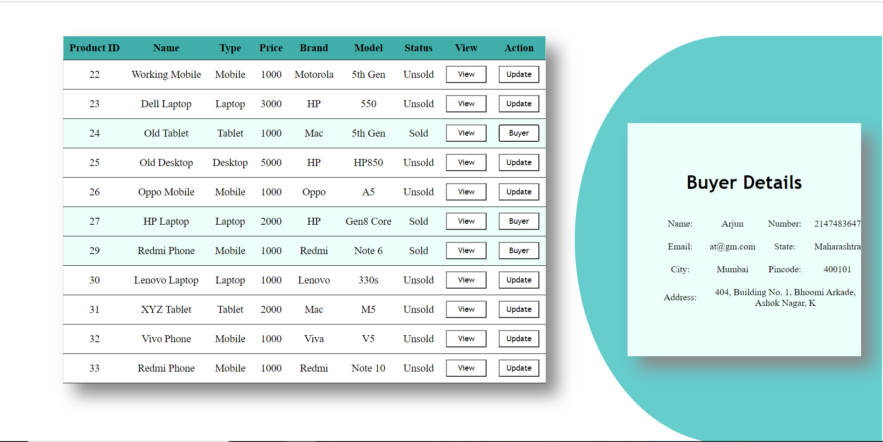

Update Device

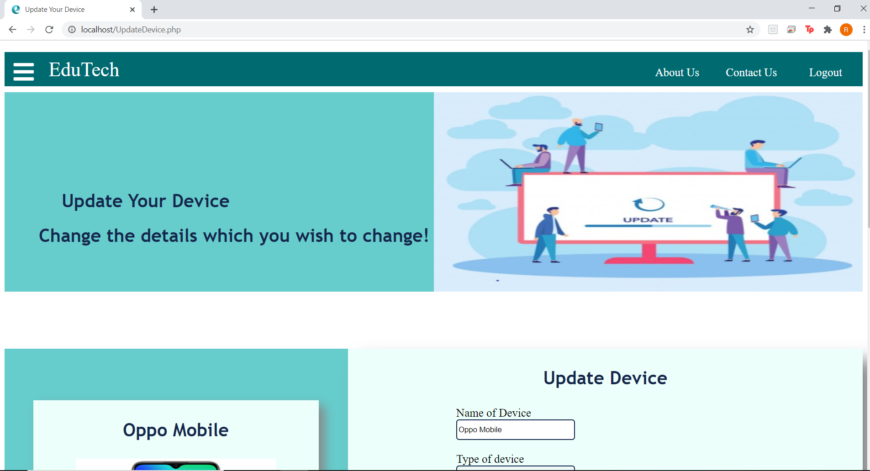

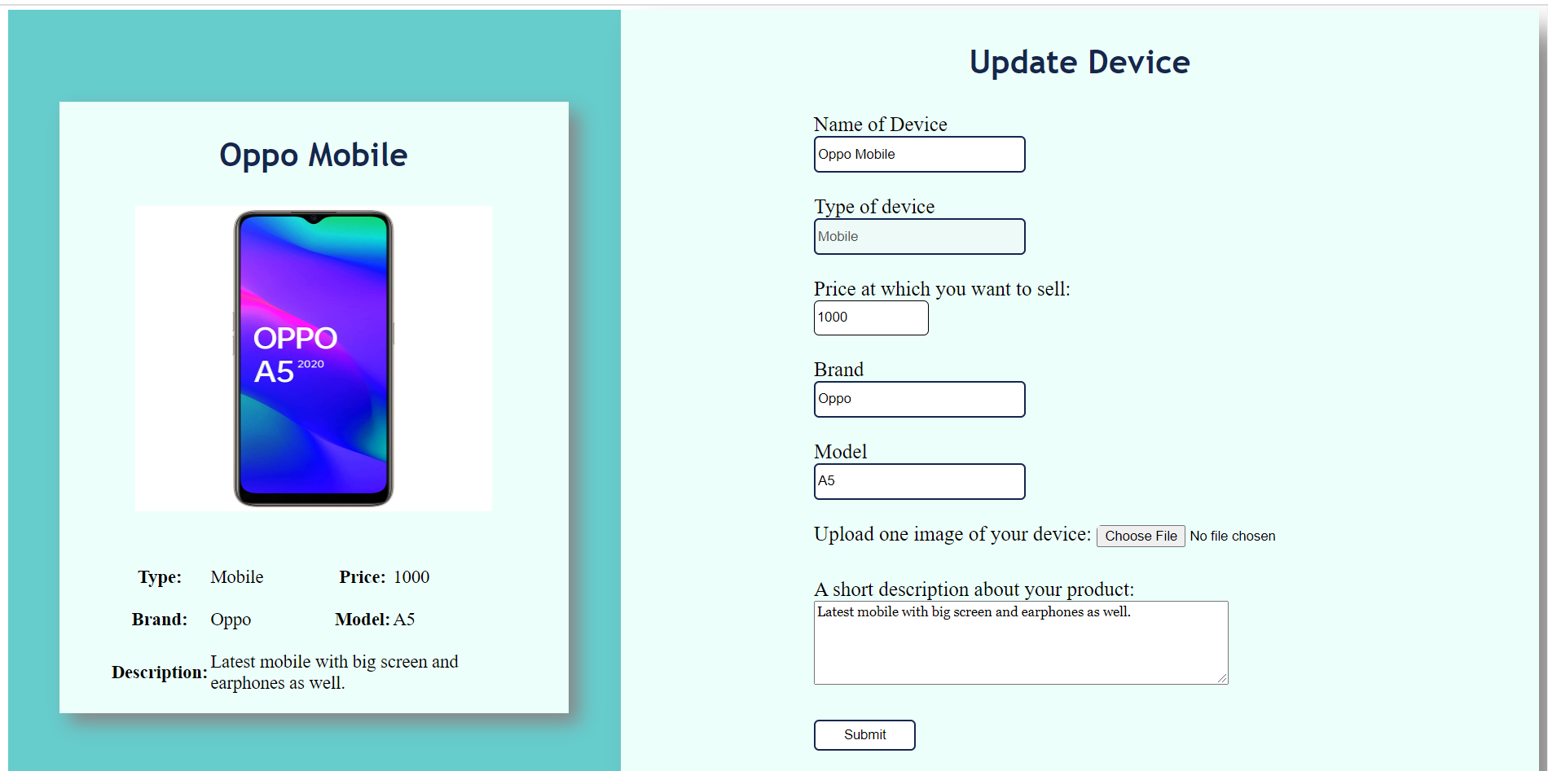

Details of the device:

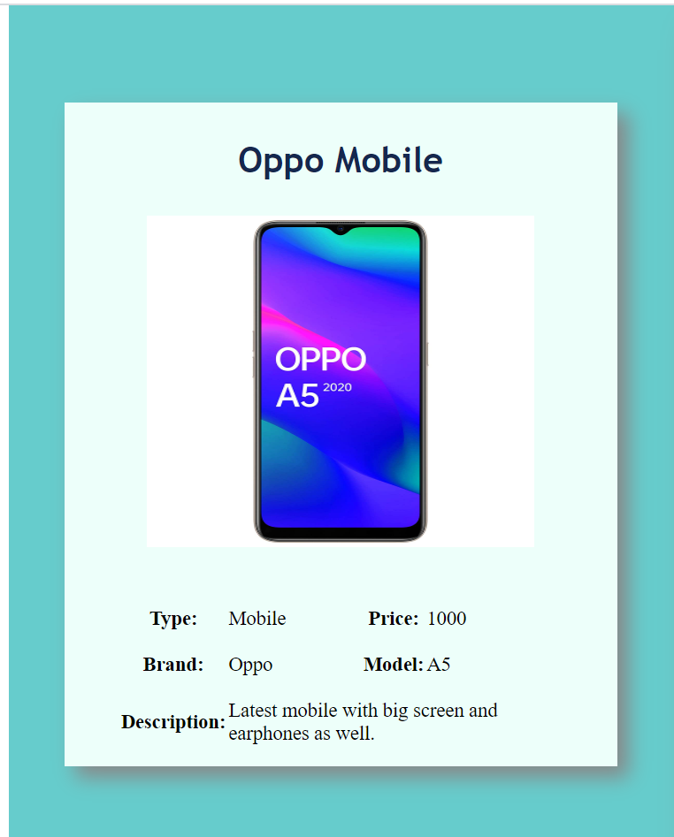

Pre Filled Form:

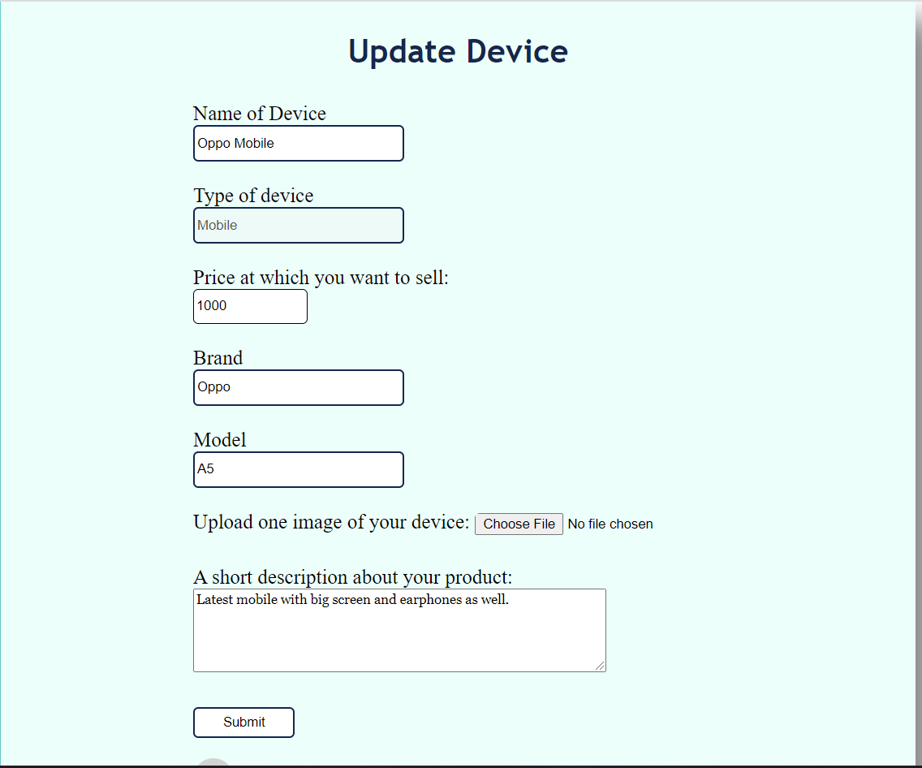

To delete a device

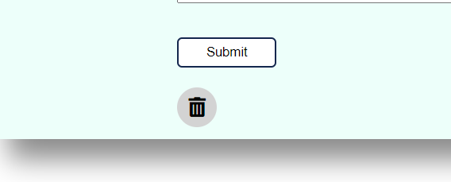

Buyer

Buyer homepage with its menu options.

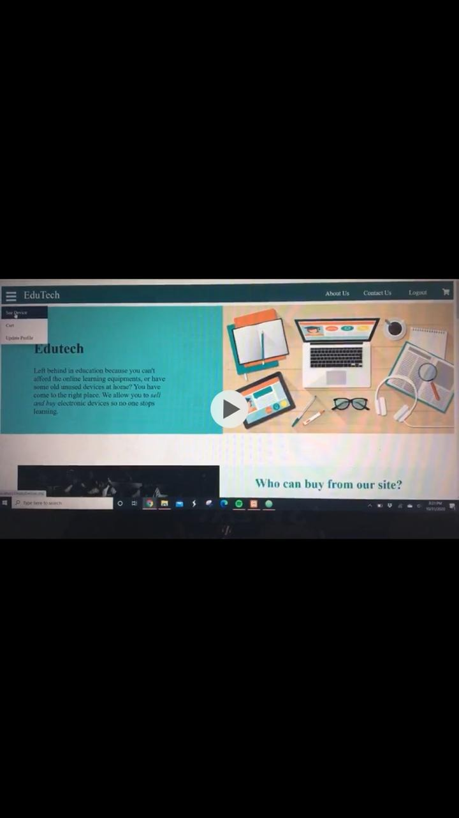

The display devices page with the filters to use for specific devices to be searched.

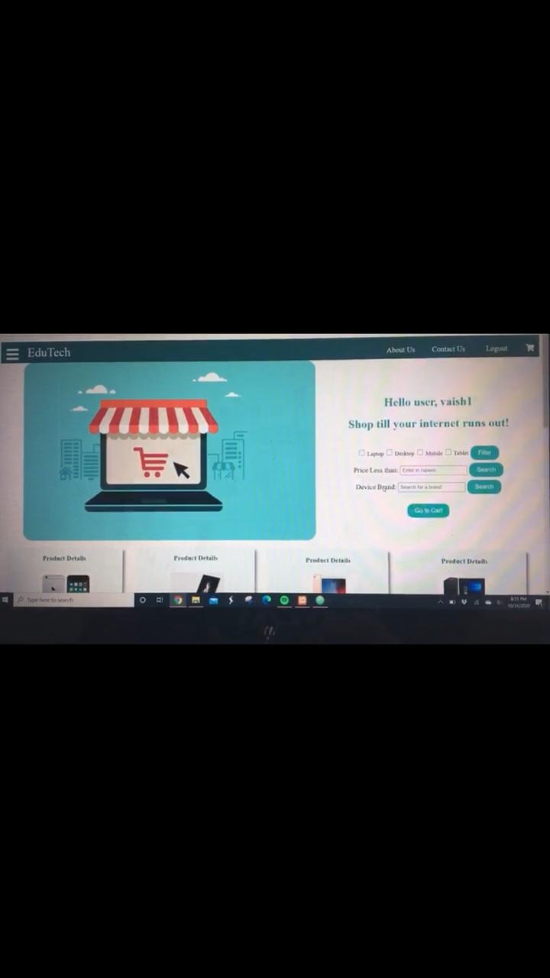

Product card for the electronic devices available for purchase.

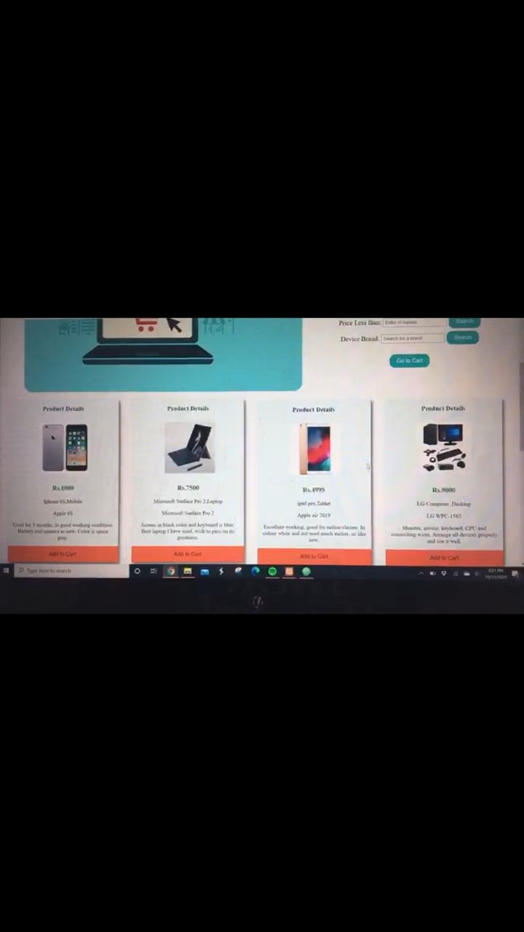

The cart page with the devices selected with their details and also a delete option for the product.

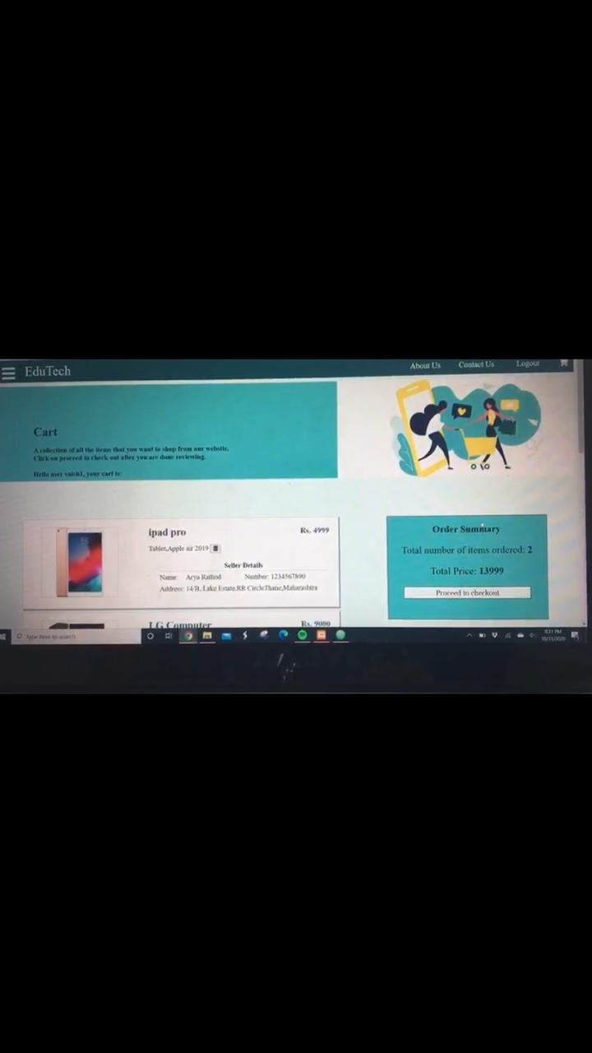

After proceeding to checkout, the buyer is led to the payments page to enter his billing details. After checking out, the buyer is redirected to the homepage.

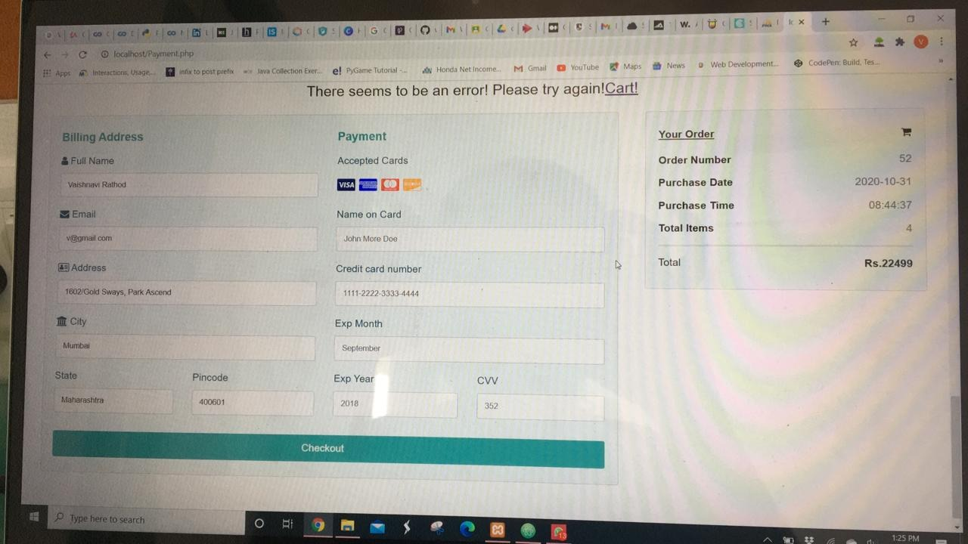

For updating user details, we have change username, change password, update profile details and delete the account.

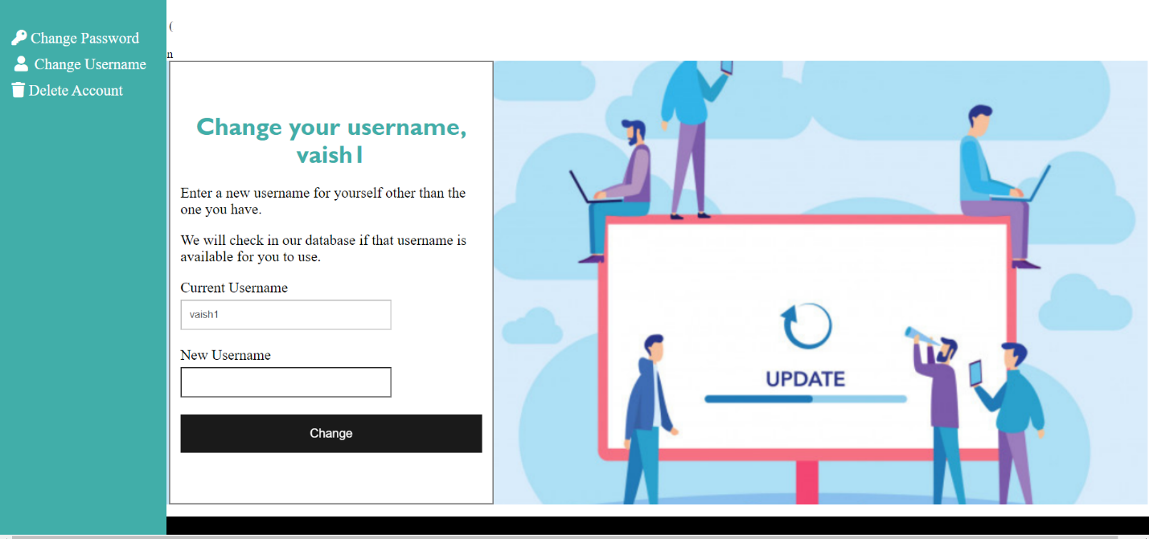

About Us

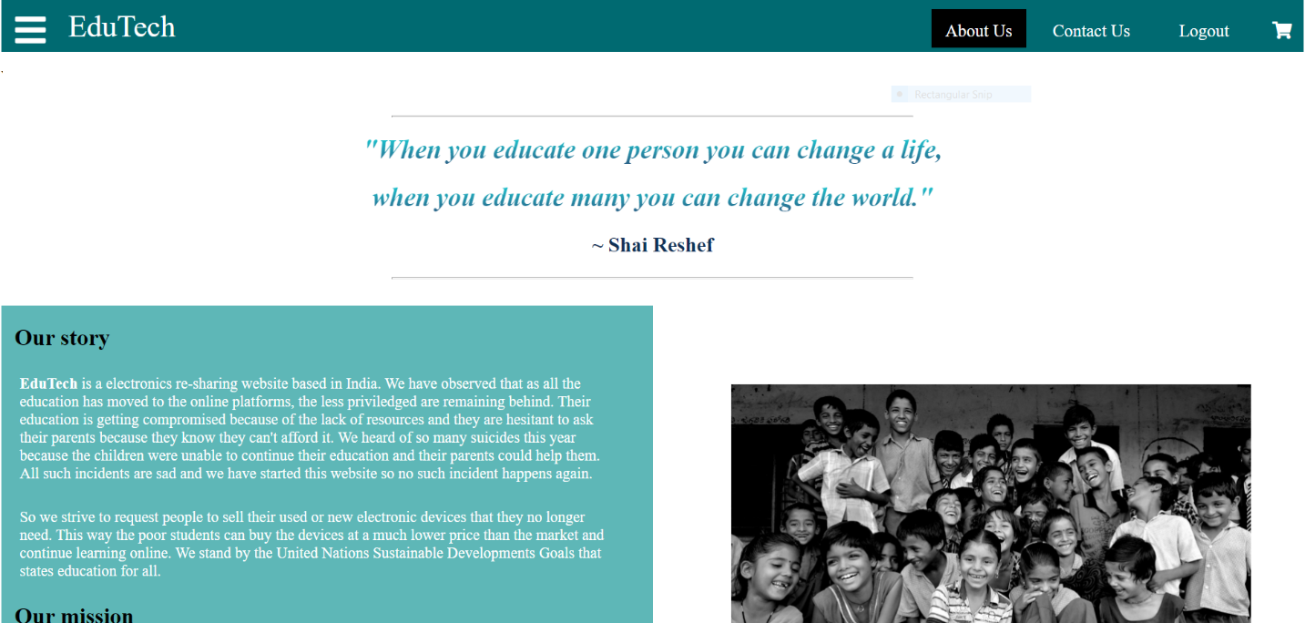

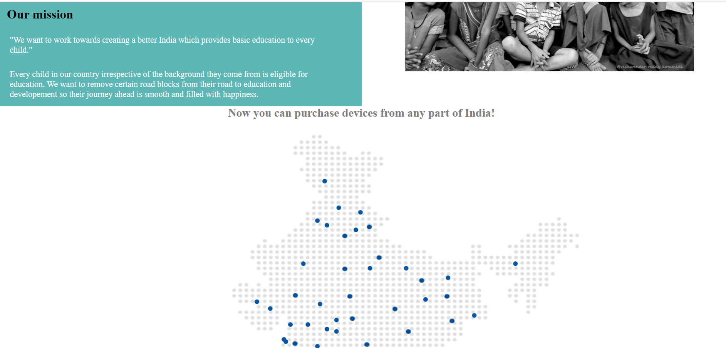

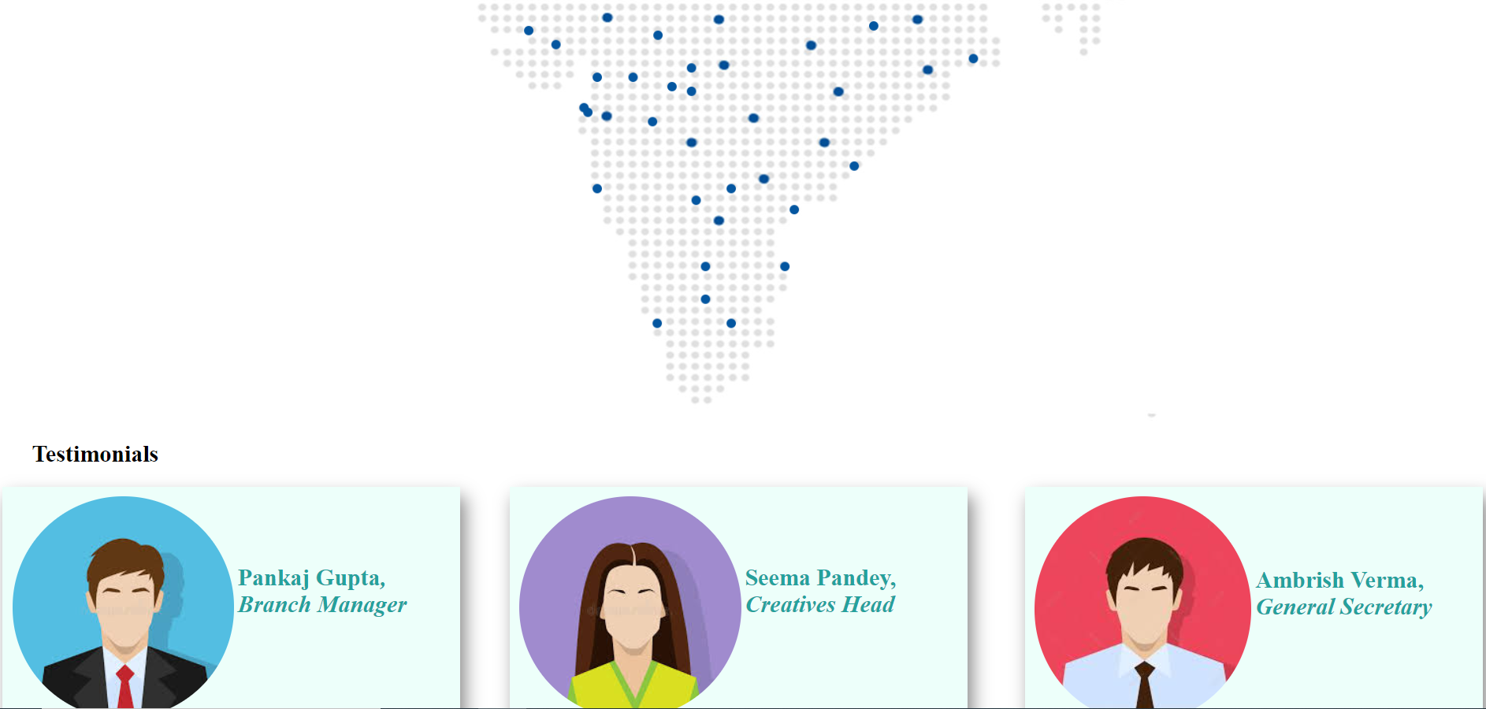

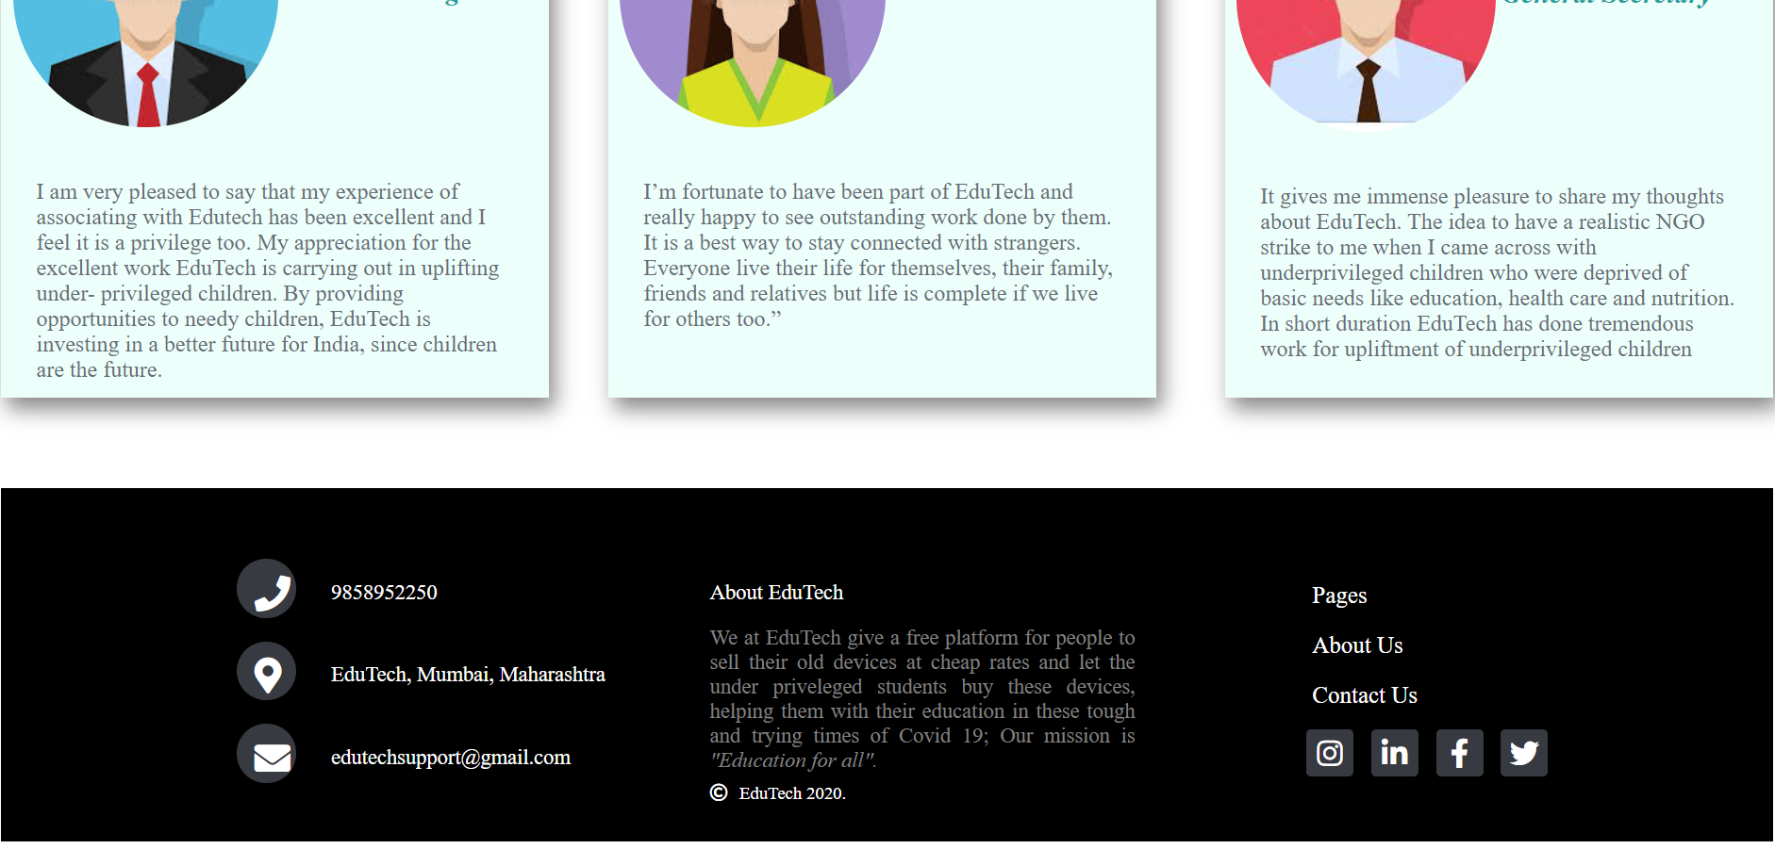

Contact Us

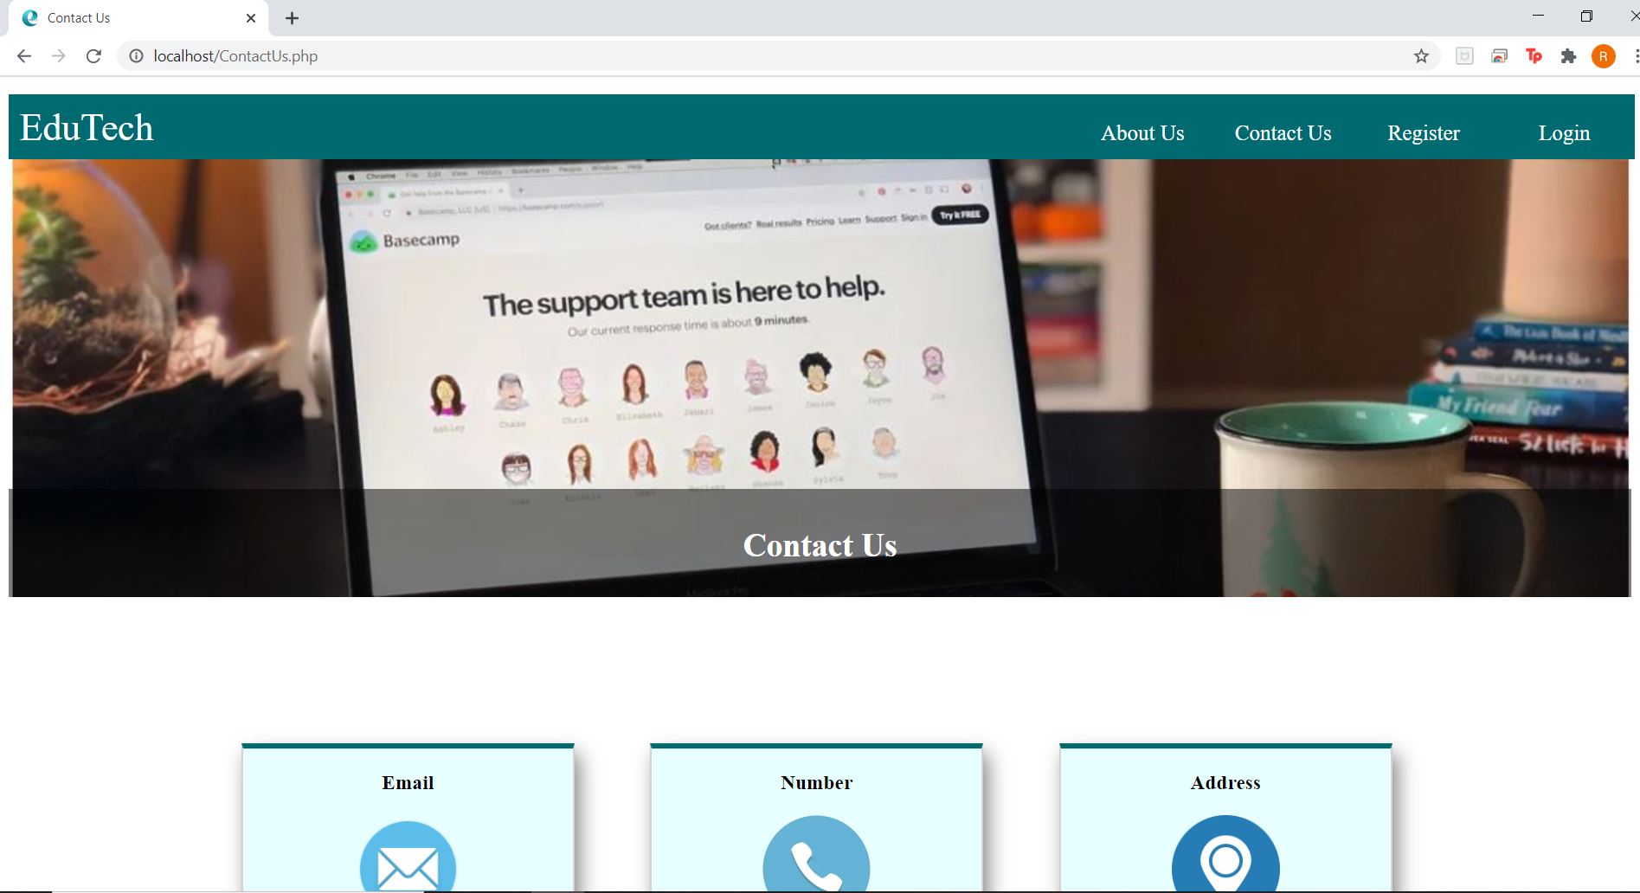

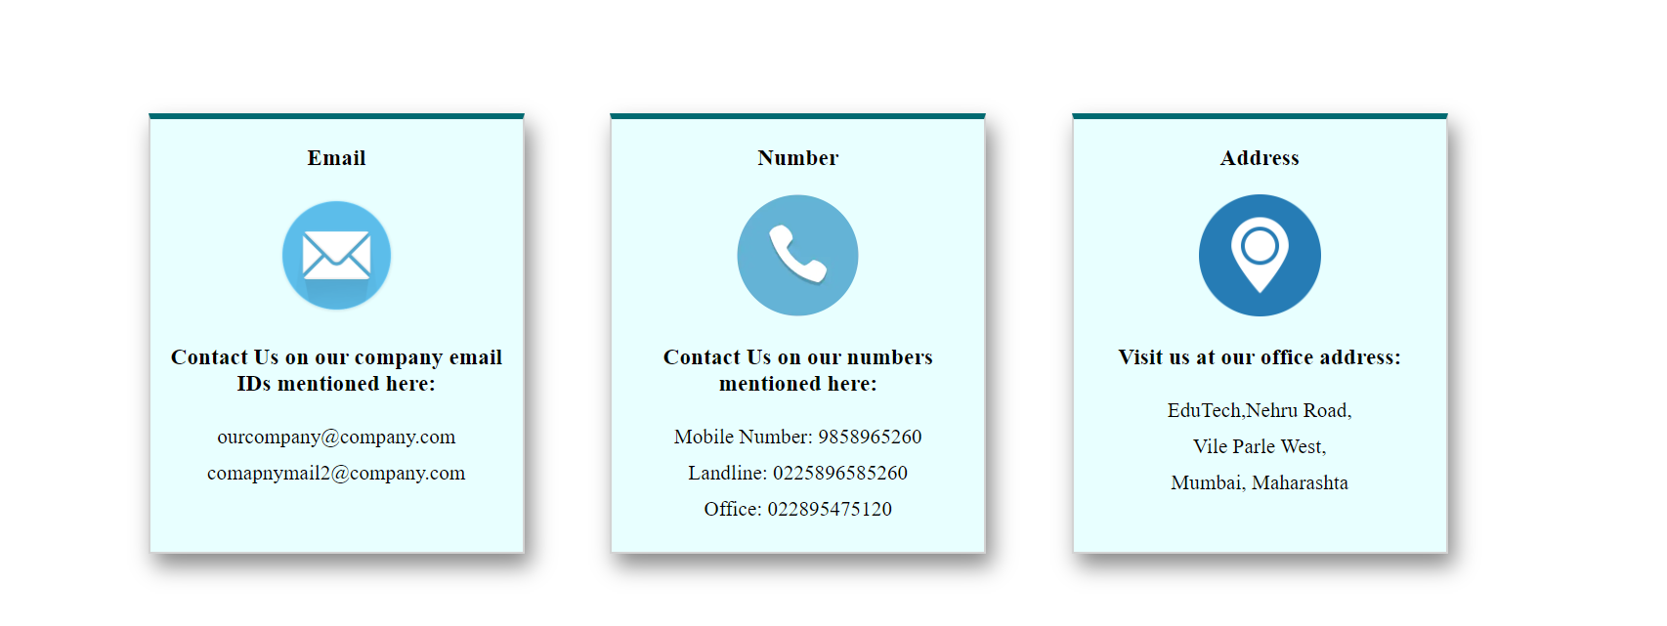

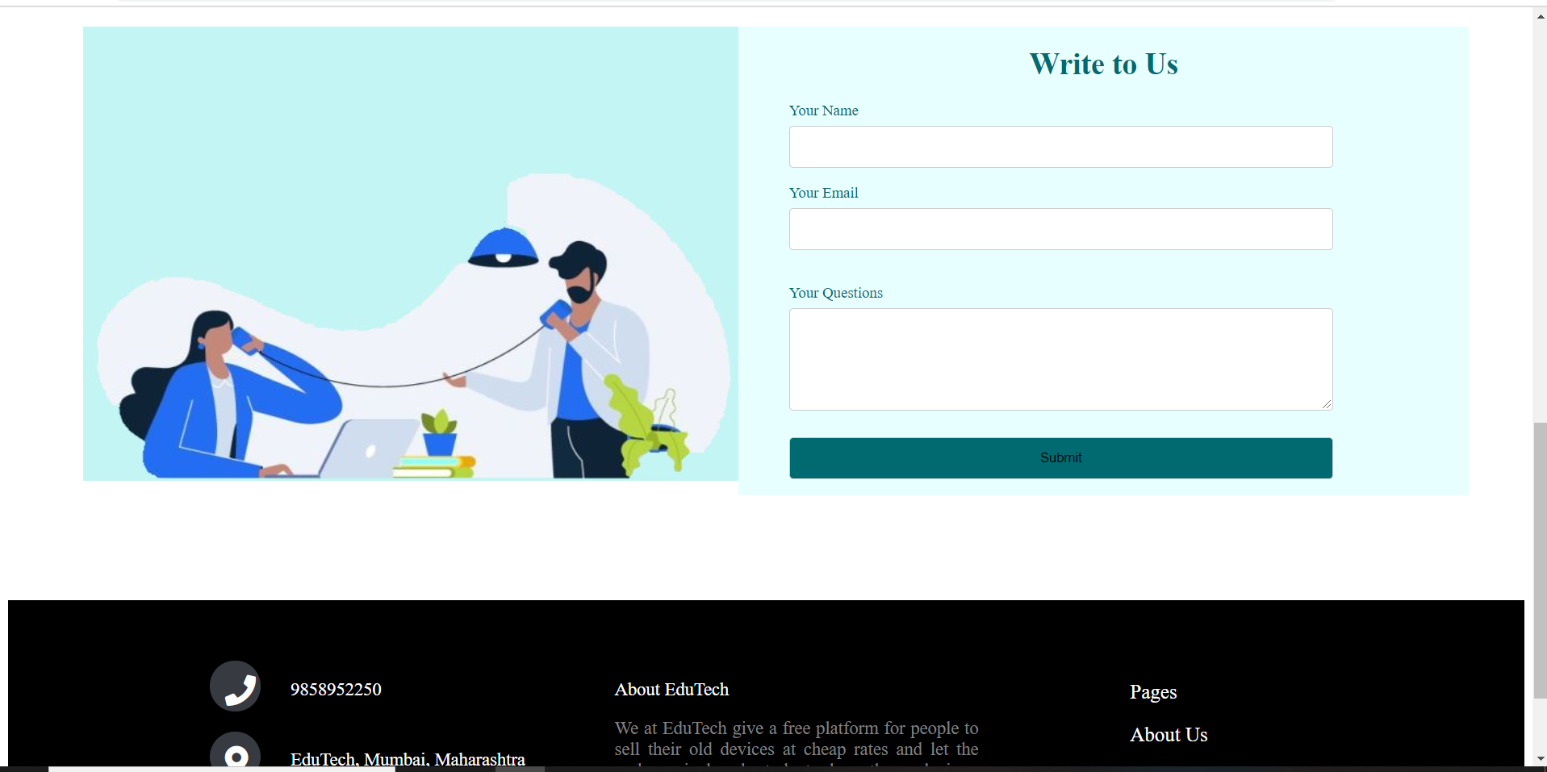

Terms and conditions

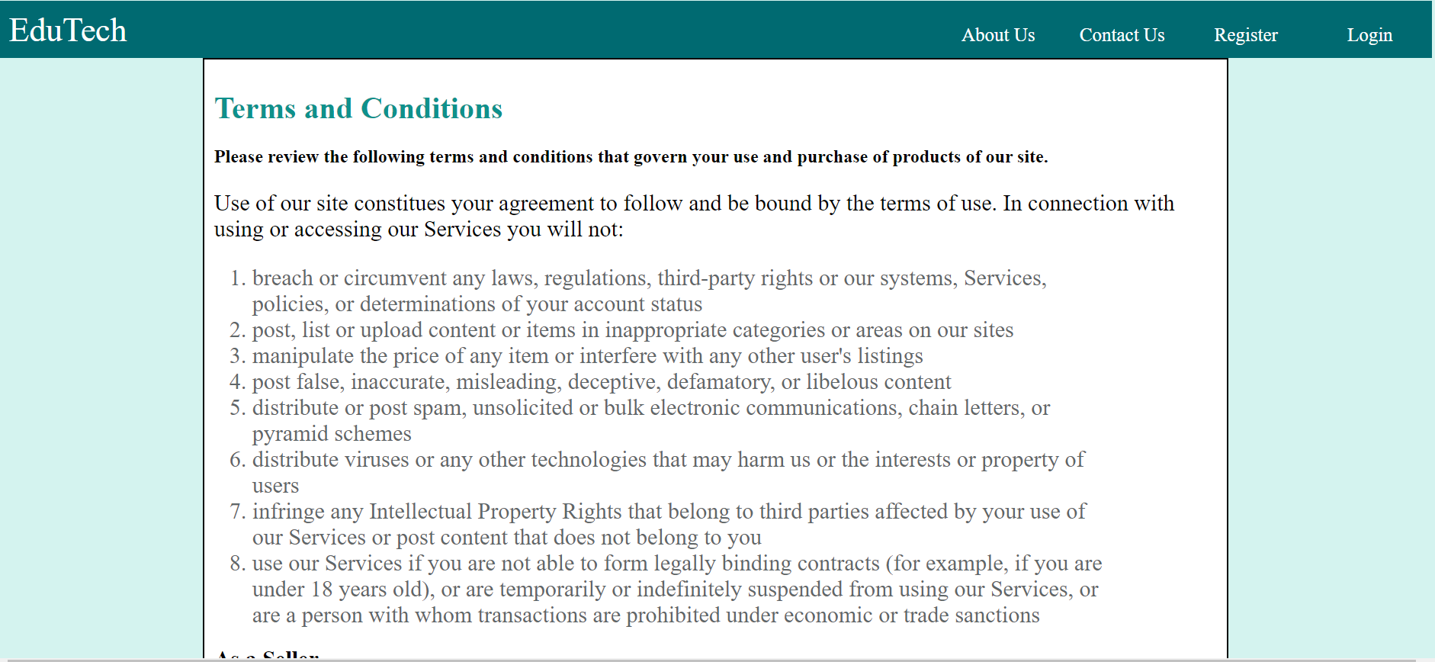

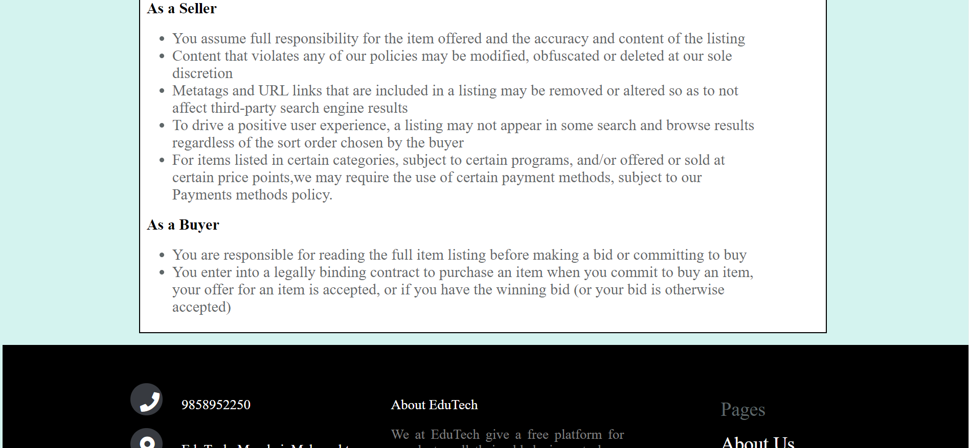

Database

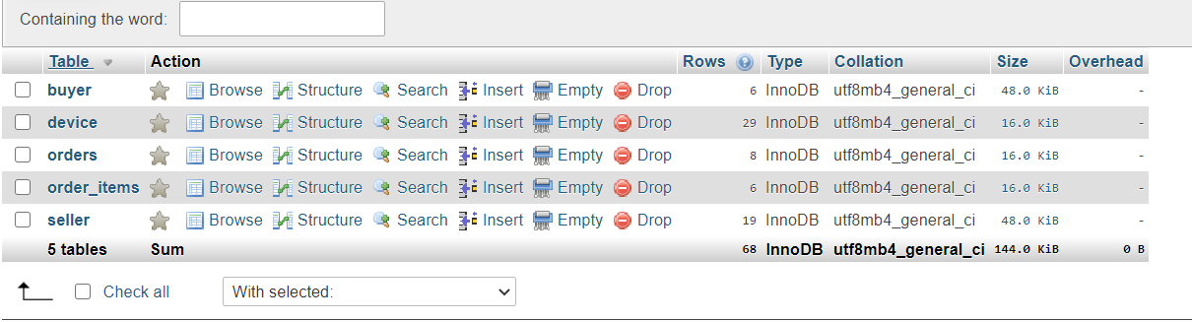

Buyer Table:

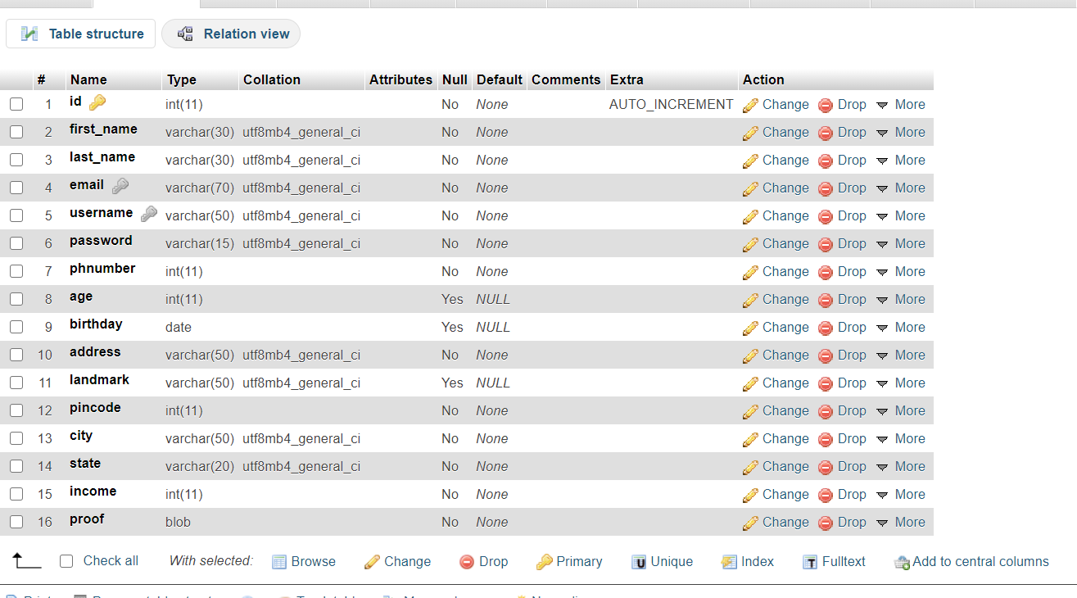

Seller Table:

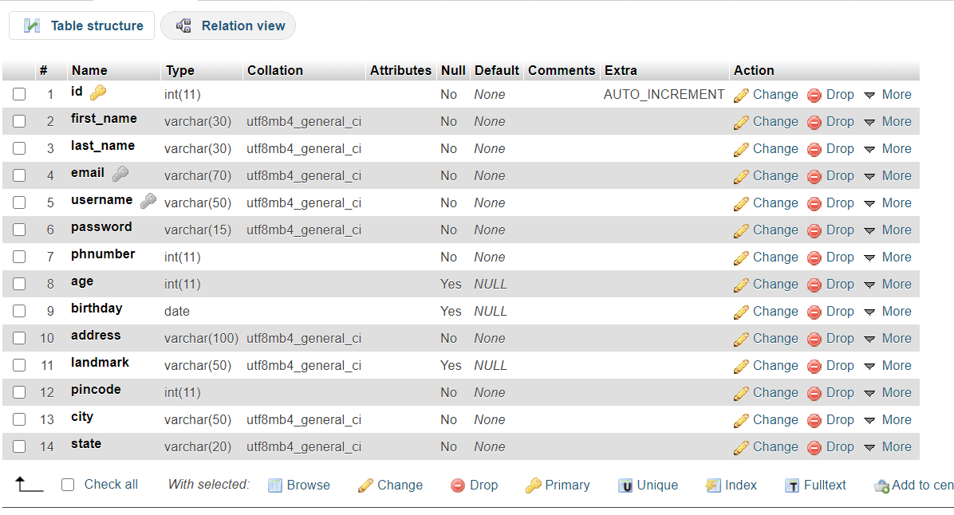

Device Table:

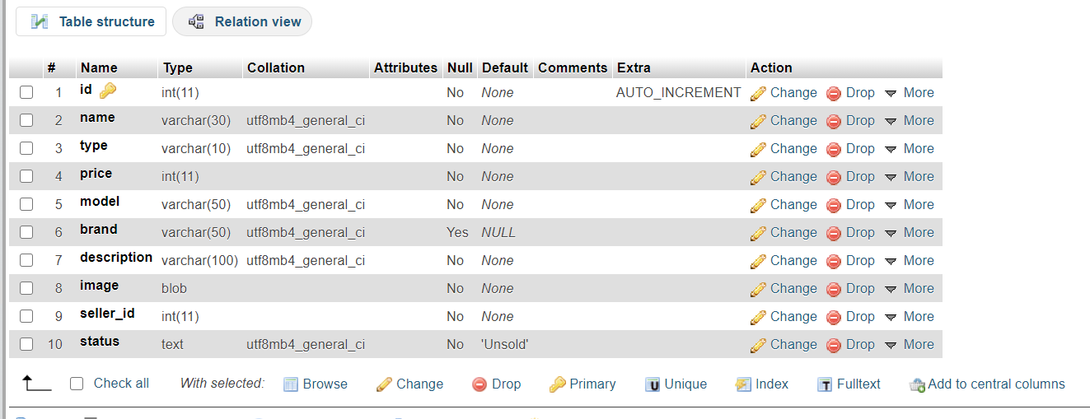

Orders Table:

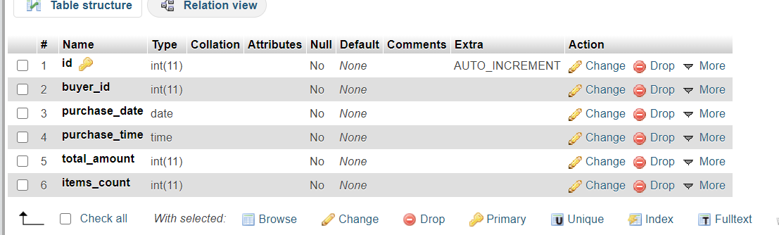

Order Items Table:

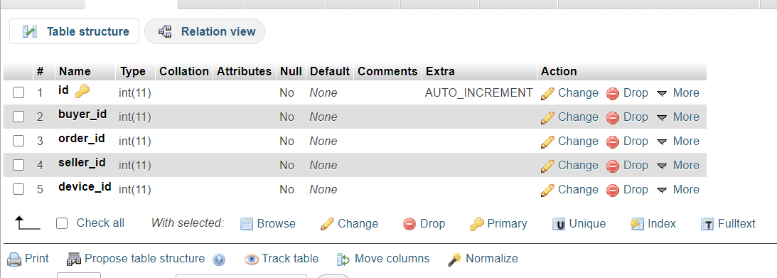

**Conclusion and Future Scope**

After completing this website, we have gained a through knowledge of HTML, CSS, JavaScript and PHP. We were able to implement all the concepts that were taught to us in class in a very free and creative manner and this website was a great learning experience. We have successfully created a dynamic website along with front end and backend. The aim of our project and website was to apply our technical knowledge for the betterment of the world and we have successfully done that.

For the future, we wish to make this website live. We also wish to add another module- NGOs. NGOs play a huge role in the lives of underprivileged children and we want a module in our website where NGOs can register with us and purchase devices for children.

We also plan to work on the logistics of our concept. Currently the seller needs to courier the devices, but we want to make that part easier so that more people will be motivated to sell on our website.

**Societal Applications**

Covid-19 has been our life since March,2020 now and any people are suffering because of it. Schools have started implementing online education making electronic devices necessary. Nationally over 320 million children are out of the classroom. As a result, education has changed dramatically, whereby teaching is undertaken remotely and on digital platforms. Under privileged children have the passion and interest to learn and study and are very keen about their education. They don't have financial backing and access to electronic devices and their parents are barely able to afford basic necessities. Our website helps out such students by providing them with devices sold by other at cheap rates, letting them continue their education.